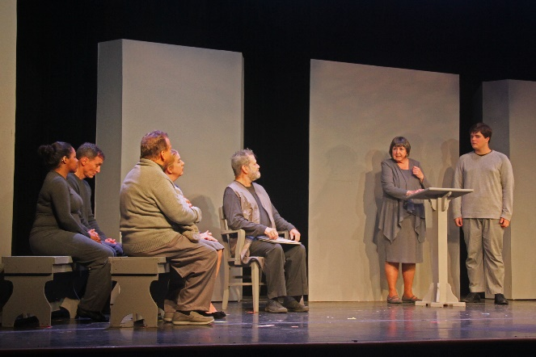

Directed by Jennifer Lyman
Produced by Leslie Teitel and Marg Soroos
Cast: Jim Pearson (Father), Debbie Gray (Mother), Katherine Watters (Lily), Brett Medley (Jonas), McKenzie Blair (Asher), Alex Beach (Fiona), Patricia Spencer-Smith (Larissa/Chief Elder), Paul Donahoe (Giver), Chanel Lancaster (Ensemble), Richard Isaacs (Ensemble), Emily Martineau (Ensemble), Angela Gray (Ensemble), Alex Harris (Ensemble)
"Thoughtful, well-done show..." MD Theater Guide Review
“The Giver” is a difficult play for a theater to do and I give full kudos to Aldersgate for tackling this subject…The cast do well playing the restrained range of allowed emotions...The set design by John Downing provides the visual structure of this world. Everything is shades of gray and is uniform. When a red book pops up on the Giver’s bookshelf, it’s mesmerizing... The set is further enhanced with projections by Jon Roberts—there are projections on the side walls of the space as well as a screen behind the built set.” MD Theater Guide, October 1, 2019
https://mdtheatreguide.com/2019/10/theatre-review-the-giver-at-aldersgate-church-community-theater/
https://dcmetrotheaterarts.com/2019/09/29/review-the-giver-at-aldersgate-church-community-theater/
TICKETS ARE AVAILABLE AT THE DOOR AFTER ONLINE SALES END!

